Duplicate Report

T-code → ZDUPINV - Advanced SImilar Invoice Report

CAG - Data Download

- Enter into SM37 and look for the daily automatic job:

D_FIAPDUPINVREP

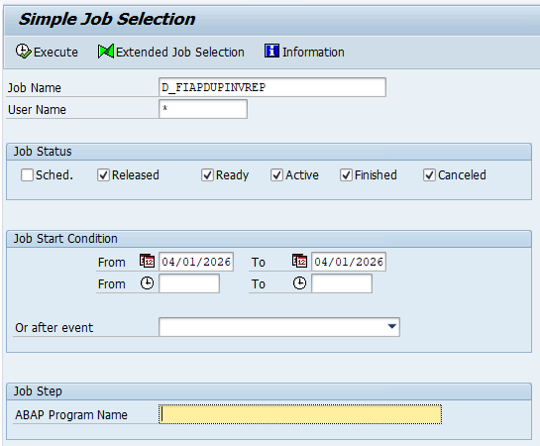

- Select the job and click on Spool

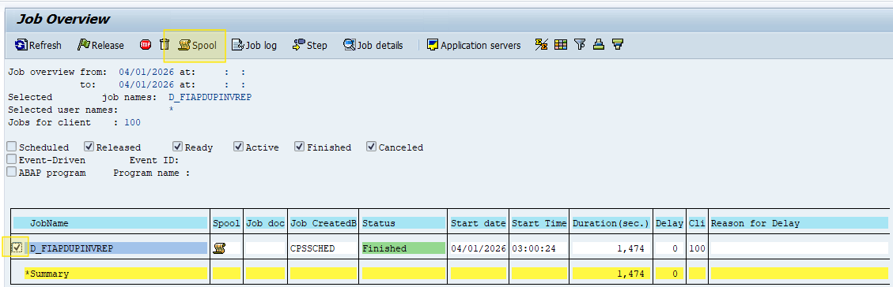

- Click on Type

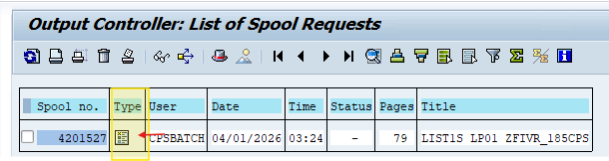

- Download the data into a Google Sheets

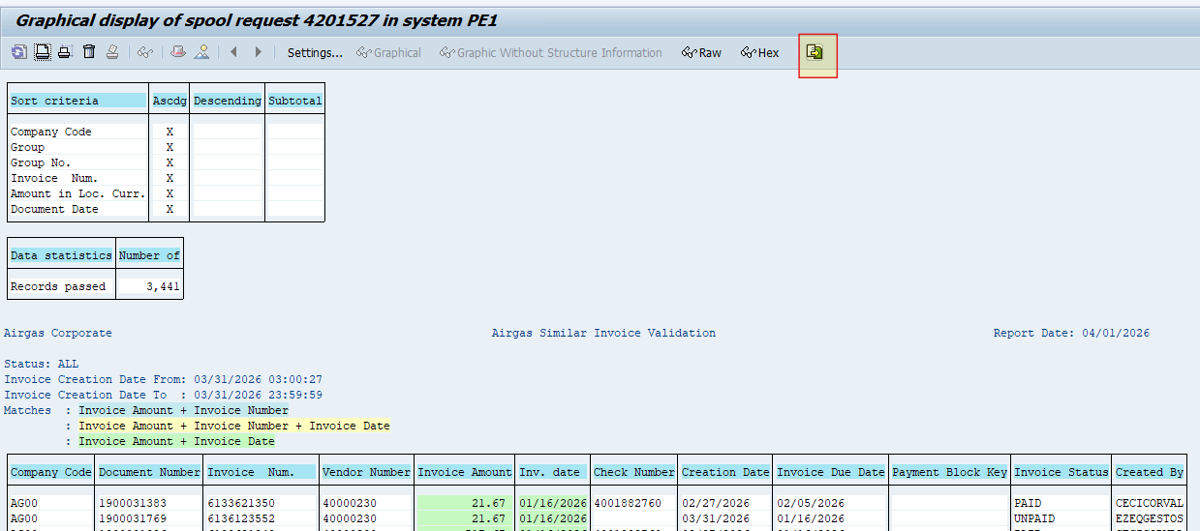

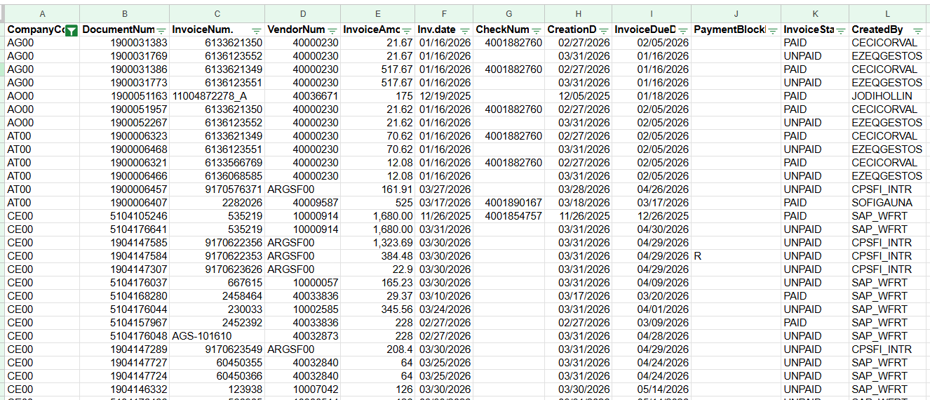

- Paste the data into the daily template and, if necessary, scroll down the formulas from M to Q

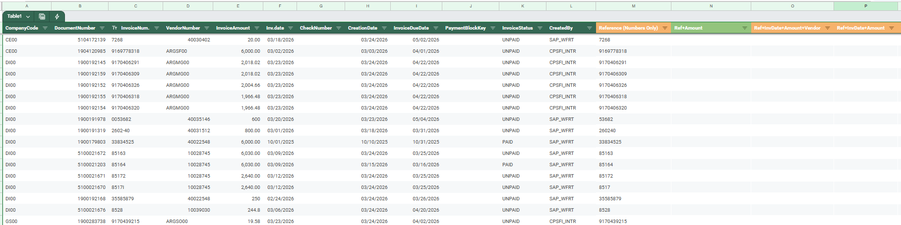

- Copy and paste the lines that are under “Review Possible Duplicate” to the third tab and assign a case number in column A (considering the last case number assigned to the previous day cases)

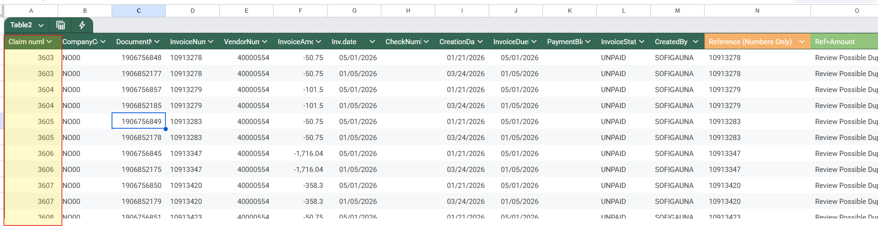

- From FBL1N, download the document numbers from this final tab to get the correct amount sign. Once downloaded, paste it into the daily template and, with a VLOOKUP formula, bring the correct amounts to the ‘Final’ sheet:
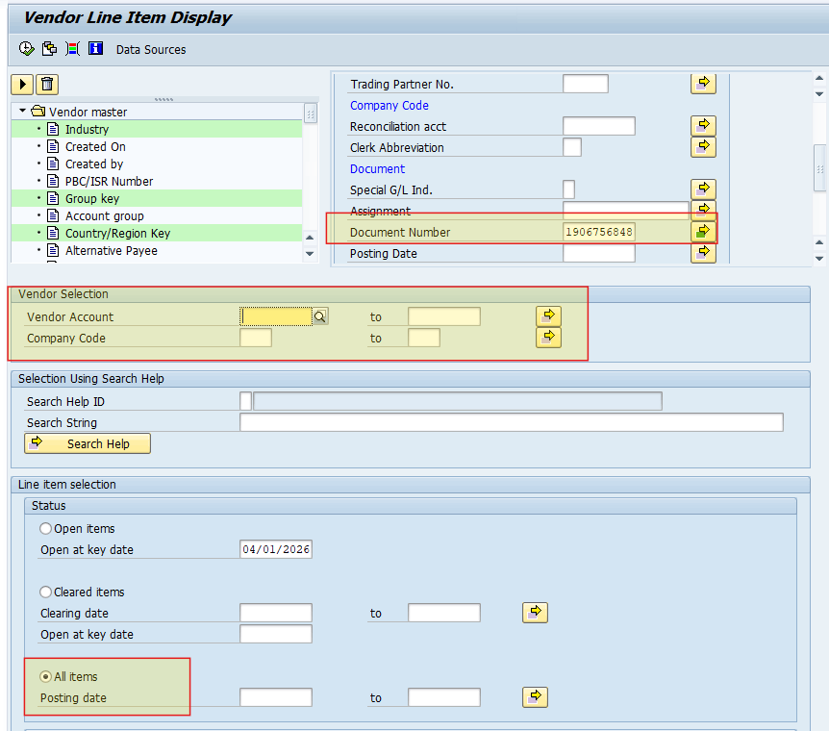

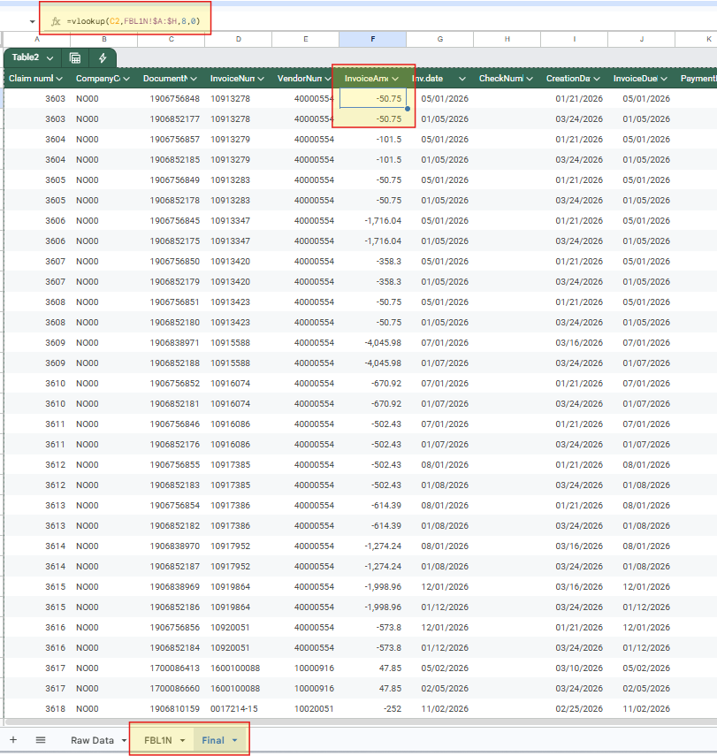

- Paste the final data into the consolidated Duplicate Report
- Block in SAP (from tcode FBL1N) all the items under ‘UNPAID’ status in column L with payment block B (this will help us prevent duplicate payments)

I&E - Assignment

- In T-code ZVIM_VA2 look for the document numbers:
Fields to be completed:
- Supplier with the vendor numbers from column E
- Accounting Document Number with the document numbers from column C
- Reference with the invoice numbers from column D
- Company Code with *

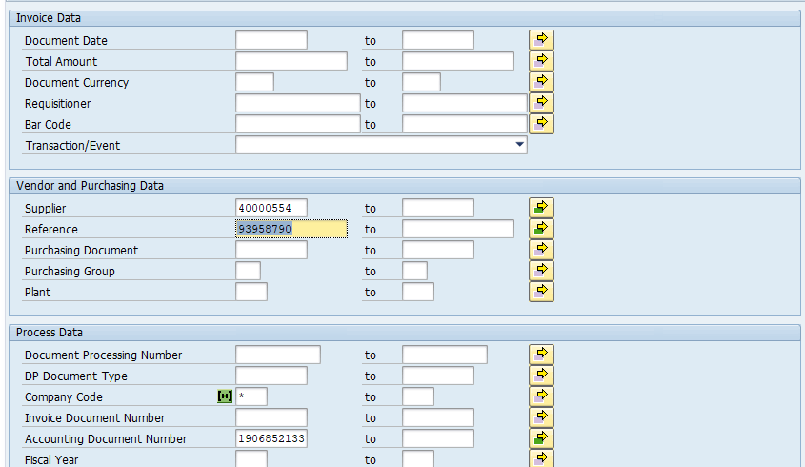

- Download the data and paste it into the Duplicate Report in tab ‘Doc Type’ (it is cumulative)

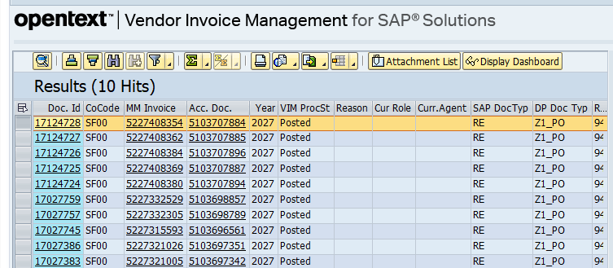
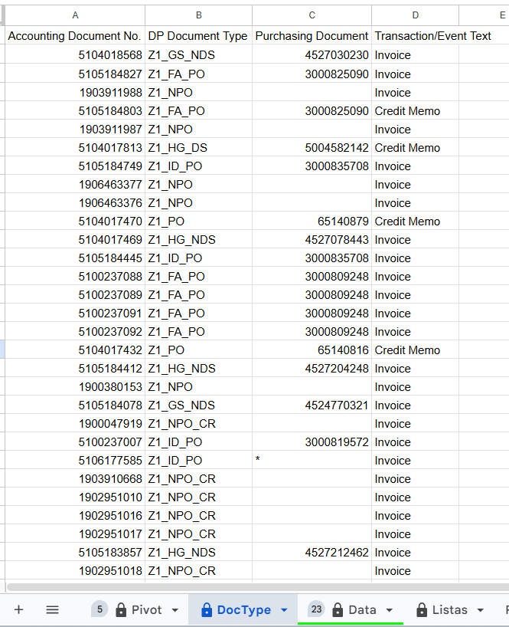

- If necessary, scroll down the formulas from columns S-U:

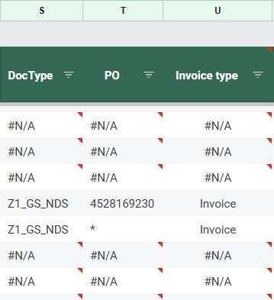

- To assign the cases, I&E team looks at column S and, depending on the type of document, they assign it to the corresponding team.
If a document brings N/A, then they search the document into FBL1N to determine who processed it.

